Project Report

|  |  |
| --- | --- |
| **Team ID** | **PNT2022TMID28453** |
| **Project Name** | **Smart waste management system for metropolitan cities** |
| **Team Lead** | **SRIRAM V** |
| **Team Member 1** | **SHARATH VIGNESH S** |
| **Team Member 2** | **RAGHUL S** |
| **Team Member 3** | **PONSHAM S** |

# INTRODUCTION

## Project Overview:

Our waste generation is constantly growing to form a [global garbage crisis. E](https://evreka.co/blog/global-garbage-crisis-and-high-tech-solutions/)ven though we indulge in creating a more sustainable and greener, we still fail to handle our waste generation and management. Combining technology support with a vision of social, economic and environmental sustainability is the best way out of this problem. It is done in the following manner. The smart bin system undergoes a thorough system check and battery level monitoring in order to function efficiently. If the battery level is found to be low, it has to be recharged immediately, else it can proceed to the next step. The threshold level levels of the bin are indicated my multiple sensors attached to bin. If the garbage exceeds the level, then an alert message is sent to the garbage collectors as well as to the municipality or area administration. The area in which garbage is found to overflow is allocated to respective garbage collectors in the form of messages through GSM system. Once the waste bin is emptied, an information update is sent to the municipality and server is updated. This is how the waste from bins can be efficiently handled and managed using technology which in turn keeps the environment clean and healthy.

## Purpose:

We amalgamate technology along with waste management in order to effectively create a safe and a hygienic environment. Smart waste management is about using technology and data to create a more efficient waste industry. Based on IoT (Internet of Things) technology, smart waste management aims to optimize resource allocation, reduce running costs, and increase the sustainability of waste services. This makes it possible to plan more efficient routes for the trash collectors who empty the bins, but also lowers the chance of any bin being full for over a week. A good level of coordination exists between the garbage collectors and the information supplied via technology. This makes them well aware of the existing garbage level and instigate them whenever the bins reach the threshold level. They are sent with alert messages so that they can collect the garbage on time without littering the surrounding area. The fill patterns of specific containers can be identified by historical data and managed

accordingly in the long term. In addition to hardware solutions, mobile applications are used to overcome the challenges in the regular waste management system, such as keeping track of the drivers while they are operating on the field. Thus, smart waste management provides us with the most optimal way of managing the waste in an efficient manner using technology

# LITERATURE SURVEY:

## Existing problem:

Waste management has become an alarming challenge in local towns and cities across the world. Often the local area bins are overflowing and the municipalities are not aware of it. This affects the residents of that particular area in numerous ways starting from bad odour to unhygienic and unsafe surroundings. Poor waste management - ranging from non-existing collection systems to ineffective disposal -causes air pollution, water and soil contamination. Open and unsanitary areas contribute to contamination of drinking water and can cause infection and transmit diseases. Toxic components such as Persistent Organic Pollutants (POPs) pose particularly significant risks to human health and the environment as they accumulate through the food chain. Animals eating contaminated plants have higher doses of contaminants than if they were directly exposed. Precipitation or surface water seeping through waste will absorb hazardous components from landfills, agricultural areas, feedlots, etc. and carry them into surface and groundwater. Contaminated groundwater also poses a great health risk, as it is often used for drinking, bathing and recreation, as well as in agricultural and industrial activities. Landfills and waste transfer stations can attract various pests (insects, rodents, gulls, etc.) that look for food from waste. These pests can spread diseases through viruses and bacteria (i.e., salmonella and e-coli), which are a risk to human health.

## References:

**PAPER 1:**

**TITLE:** IoT Based Waste Management for Smart City **AUTHOR NAME:** Parkash Tambare, Prabu Venkatachalam **PUBLICATION YEAR:** 2016 **DESCRIPTION:**

In the current situation, we frequently observe that the trash cans or dust cans that

are located in public spaces in cities are overflowing due to an increase in the amount of waste produced each day. We are planning to construct “IoT Based Waste Management for Smart Cities” to prevent this from happening because it makes living conditions for people unsanitary and causes unpleasant odours in the surrounding area. There are numerous trash cans scattered throughout the city or on the campus that are part of the proposed system. Each trash can is equipped with a low-cost embedded device that tracks the level of the trash cans and an individual ID that will enable it to be tracked and identified.

## PAPER 2:

**AUTHOR NAME:** Mohammad Aazam, Marc St-Hilaire,

Chung-Horng Lung, Ioannis Lambadaris

## PUBLICATION YEAR: 2016 DESCRIPTION:

Each bin in the Cloud SWAM system that Mohammad Aazam et al suggested has sensors that can detect the amount of waste inside. There are separate bins for organic, plastic/paper/bottle/glass, and metal waste. This way, each form of waste is already divided, and it is known how much and what kind of waste is collected thanks to the status. Different entities and stakeholders may benefit from the accessibility of cloud-stored data in different ways. Analysis and planning can begin as soon as garbage is collected and continue through recycling and import/export-related activities. Timely garbage collection is provided via the Cloud SWAM system. A timely and effective method of waste collection improves health, hygiene, and disposal.

## PAPER 3:

**TITLE:** Arduino Microcontroller Based Smart Dustbins for Smart Cities **AUTHOR NAME:** K. Suresh, S. Bhuvanesh and B. Krishna Devan **PUBLICATION YEAR:** 2019 **DESCRIPTION:**

In this paper, a technique for cleaning up our surroundings and environment is

described. The Indian government just began work on a smart city initiative, and in order for these towns to be smarter than they already are, the garbage collection and disposal system must be improved upon. Self-Monitoring Automated Route Trash (SMART) dustbins are intended for use in smart buildings such as colleges, hospitals, and bus stops, among other places. In this study, we have employed the PIR and Ultrasonic sensors to detect human presence, the Servomotor to open the dustbin lid, and the Ultrasonic sensor to detect the level of rubbish. Signals between two trash cans are transmitted using a communication module, and the GSM module sends the message to the operator.

## PAPER 4:

**AUTHOR NAME:** Mohd Helmy Abd Wahab, Aeslina Abdul Kadir

The objective of this paper is to examine the present methods used in India for the

welfare of its people in different waste management efforts. The other goal is to offer advice on how to make Indian municipalities' trash disposal procedures better. On secondary research, this essay is founded. The system is improved by looking at the reports that have already been written about waste management and the suggestions made for improvement by planners, NGOs, consultants, government accountability organisations, and important business leaders. It provides in-depth understanding of the various waste management programmes in India and identifies areas where waste management might be improved for societal benefit. The essay makes an effort to comprehend the crucial part that our nation's official waste management sector plays in the waste management process.

**2.3 problem statement definition:**

|  |  |  |  |  |  |
| --- | --- | --- | --- | --- | --- |
| **Problem Statement (PS)** | **I am (Customer)** | **I am trying to** | **But** | **Because** | **Which makes me**  **feel** |
| PS-1 | Council | Monitor the waste in my city | I have not much effective system for  monitoring | Because of high cost | unhygienic |
| PS-2 | Council | Manage the waste in my city | I have not much effective  system for  managing | Because of more time consuming | unsafe |

# IDEATION & PROPOSED SOLUTION:

## Empathy map canvas:

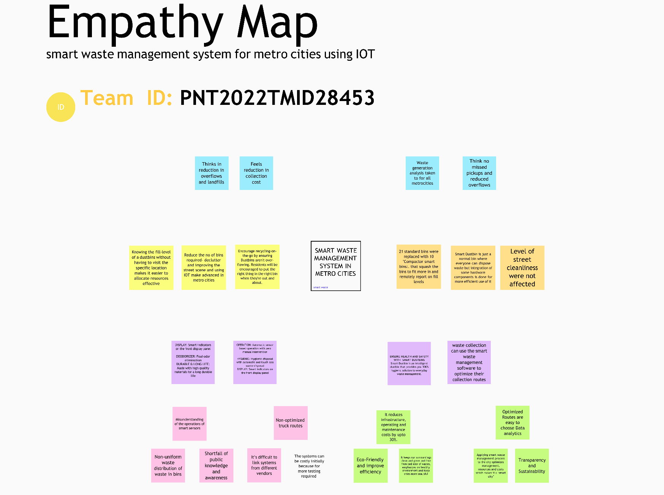

* 1. **Ideation & Brainstorming:**

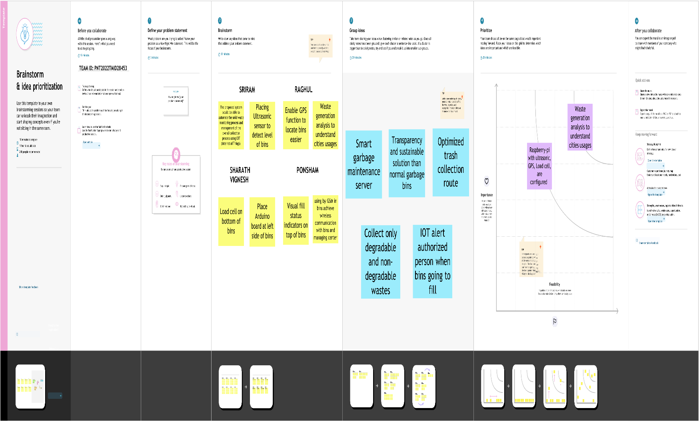

## Proposed Solution:

|  |  |  |
| --- | --- | --- |
| **SI No.** | **Parameter** | **Description** |
| 1. | Problem Statement (Problem to be solved) | Detecting the level of garbage and informing the garbage collectors through a proper communication channel about the garbage level and alerts them to collect it at a  specified time efficiently. |
| 2. | Idea / Solution description | By using fill level sensors we can detect the garbage level. Improving the communication channel using proper technology like WiMAX. Using GPS for tracking the location of bin and sorting out the short routes.  Using cloud service for the storage purpose. |
| 3. | Novelty / Uniqueness | By using IoT, GPS and GSM like technologies which if properly used in the establishment of this project helps to detect the garbage level and intimating about it to the authority and initiating them to collect the garbage on  time. |
| 4. | Social Impact / Customer Satisfaction | It keeps our surroundings clean and green and free from bad odour of wastes, emphasizes on healthy environment.  Reduces air pollution |
| 5. | Business Model (Revenue Model) | Smart waste management system is an innovative and effective step to analyze the production of waste annually and it helps to find the ways to reduce the factors which  increases the waste produced. |
| 6. | Scalability of the Solution | Smart waste management can attain its scalability by still more advancement in IoT and using many sensors to detect its accurate level accurately. Its implementation can be enhanced by using 5G type of technology for faster communication. AI recycling robots can be  used in the nearer future. |

* 1. **Problem solution fit:**

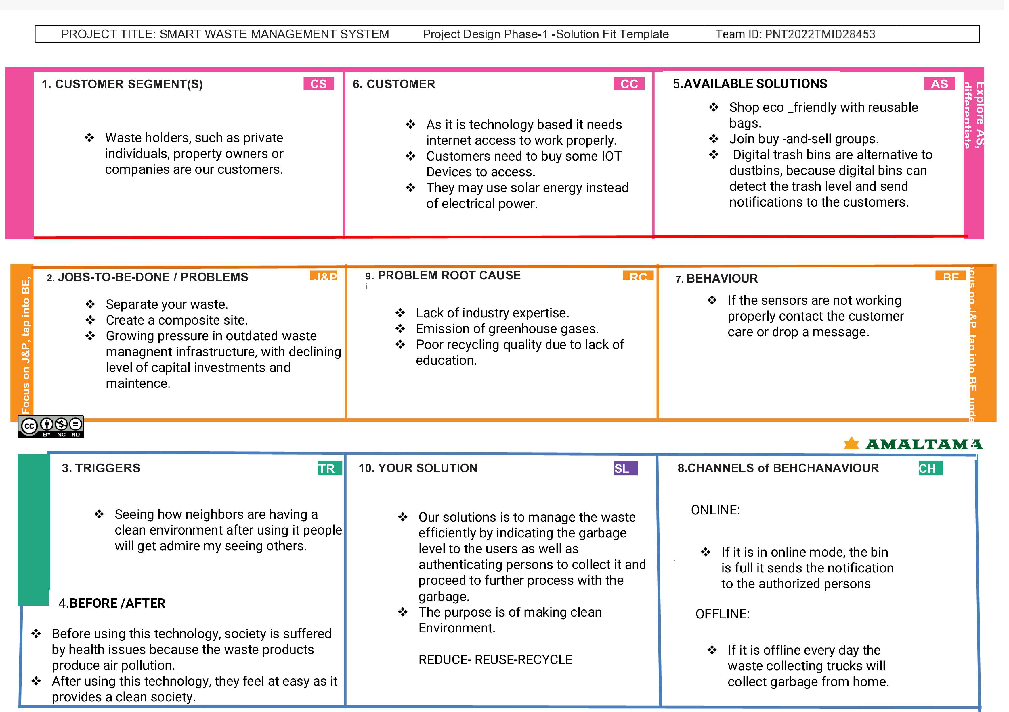

# REQUIREMENT ANALYSIS

## Functional requirement

|  |  |  |
| --- | --- | --- |
| **FR No.** | **Functional Requirement (Epic)** | **Sub Requirement (Story / Sub-Task)** |
| FR-1 | Real time bin monitoring. | The Dashboard shows statistics on the amount of fill in bins as it is being tracked by smart sensors. The application also forecasts when the bin will fill up based on past data in addition to the percentage of fill level, which is one of the features that even the finest waste management software lacks. As picks are also recognized by the sensors, you can determine when the bin was last emptied. You can get rid of the overflowing bins and cease collecting  half-empty ones using real-time data and forecasts. |
| FR-2 | Eliminate inefficient picks. | Get rid of the collection of half-empty trash cans. Picks are recognized by sensors. We can demonstrate to you how full the bins you collect are using real-time data on fill-levels and pick  recognition. |
| FR-3 | Plan waste collection routes. | Route planning for rubbish pickup is semiautomated using the tool. You are prepared to act and arrange for garbage collection based on the levels of bin fill that are now present and forecasts of approaching capacity. To find any discrepancies,  compare the planned and actual paths. |
| FR-4 | Adjust bin distribution. | Ensure the best possible bin distribution. Determine which regions have a dense or sparse distribution of bins. Ensure that each form of waste has a representative stand. You can make any required adjustments to bin position or  capacity based on past data. |
| FR-5 | Expensive bins. | We assist you in locating containers that increase collection prices. The tool determines a collection cost rating for each bin. The tool takes local average depo-bin discharge into account. The tool determines the distance from depo-bin discharge  and rates bins (1–10). |

|  |  |  |
| --- | --- | --- |
| FR-6 | Detailed bin inventory. | On the map, you can see every monitored bin and stand, and you can use Google Street View at any time to visit them. On the map, bins or stands appear as green, orange, or red circles. The Dashboard displays information about each bin,  including its capacity, trash kind, most recent measurement, GPS position, and pick-up schedule. |

* 1. **Non-Functional requirements:**

|  |  |  |
| --- | --- | --- |
| **FR No.** | **Non-Functional Requirement** | **Description** |
| NFR-1 | **Usability** | Usability is a unique and significant perspective to examine user needs, which may further enhance the design quality, according to IoT devices. Analysing how well people interact with a product may help designers better understand customers' prospective demands for waste management, behaviour, and experience in the design process when user experience is at the Centre. |
| NFR-2 | **Security** | Utilize recyclable bottles. Utilize reusable shopping bags. Spend responsibly and recycle Eat and drink in limited-use containers. |
| NFR-3 | **Reliability** | Creating improved working conditions for garbage collectors and drivers is another aspect of smart waste management. Waste collectors will use their time more effectively by attending to bins that require service rather than travelling the same collection routes and servicing empty bins. |

|  |  |  |
| --- | --- | --- |
| NFR-4 | **Performance** | The Smart Sensors assess the fill levels in bins (along with other data) numerous times each day using ultrasonic technology. The sensors feed data to Senone’s Smart Waste Management Software System, a robust cloud-based platform with datadriven daily operations and a waste management app, using a variety of IoT networks (NB-IoT, GPRS). As a consequence, customers receive data-driven decision-making services, and garbage collection routes, frequency, and truck loads are optimized, resulting in at least a 30% decrease in route length. |
| NFR-5 | **Availability** | By creating and implementing robust hardware and gorgeous software, we enable cities, companies, and nations to manage garbage more intelligently. |
| NFR-6 | **Scalability** | Using smart trash bins allows us to scale up and monitor the rubbish more efficiently while also reducing the number of bins needed in towns and cities. |

# PROJECT DESIGN:

## Data Flow Diagrams:

A Data Flow Diagram (DFD) is a traditional visual representation of the information flows within a system. A neat and clear DFD can depict the right amount of the system requirement graphically. It shows how data enters and leaves the system, what changes the information, and where data is stored A smart waste management platform uses analytics to translate the data gather in your **bins into actionable insights to help you improve your waste services.** You can receive data on metric such as:

* The first test conducted is the situation where the garbage bin is empty or its garbage level is very low
* Then, the bin is filled with more garbage until its level has surpassed the first threshold **value, which is set to 80% then the first warning SMS is being sent, as depicted**
* The first notification SMS sent by the system, once the waste reaches the level of 85% full
* The second notification SMS sent by the system, indicating that bin is at least 95% full and **the garbage needs to be collected immediately**
* Locations prone to overflow
* The number of bins needed to avoid overflowing waste
* The number of collection services that could be saved
* The amount of fuel that could be saved
* The driving distance that could be saved

## Data flow diagram:

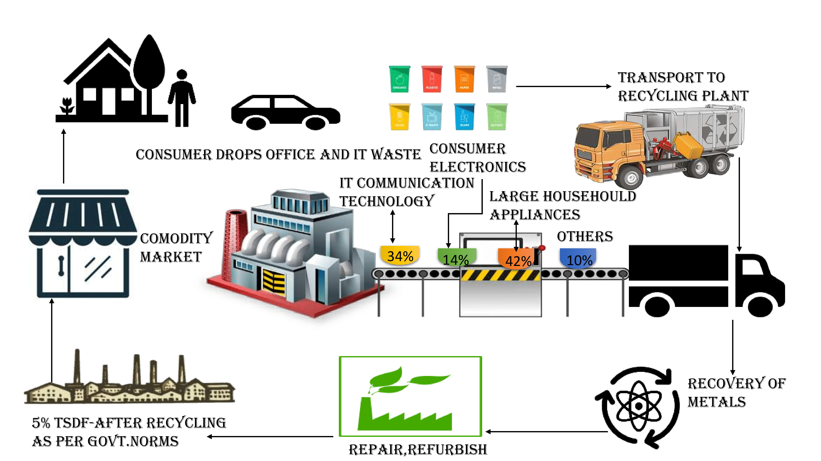

* 1. **Solution & Technical Architecture:**

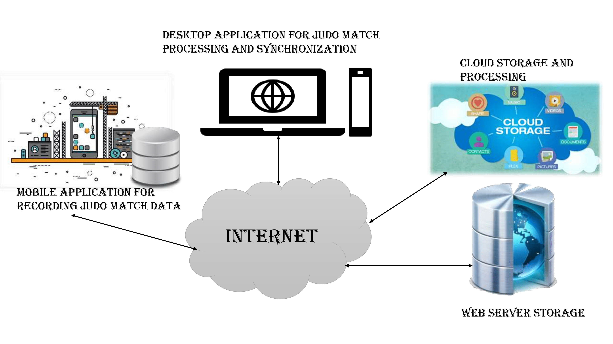

* 1. **User stories:**

|  |  |  |  |  |  |  |
| --- | --- | --- | --- | --- | --- | --- |
| **User Type** | **Functional Requirement (Epic)** | **User Story Number** | **User Story / Task** | **Acceptance criteria** | **Priority** | **Release** |

|  |  |  |  |  |  |  |
| --- | --- | --- | --- | --- | --- | --- |
| Admin(who manages  server) | Web server login | USN-1 | As a admin, I can able to track the truck driver name,  id, contact number, location, and also the location of the dustbin. | I can Manage and direct workers through web server | High | Sprint-1 |

|  |  |  |  |  |  |  |
| --- | --- | --- | --- | --- | --- | --- |
| Co-Admin | Login | USN-2 | As a co-admin I’ll monitor the workers, whether the work has been done properly, checking the availability of workers and also monitor the waste collected by the truck driver within the  scheduled time | I can monitor the  garbage bin activity | High | Sprint-1 |
| Customer (Web user) | User | USN-3 | As a user , I can able to raise queries to higher authorities about the maintenance and disposal of waste | I can raise queries | Medium | Sprint-2 |
| Customer Care Executive | Worker | USN-4 | As a customer care executive I will try to rectify the queries from customers by contacting coadmin. In case of emergency situation query can be reported to Admin. | I can attend calls and respond  people and solve their problems | High | Sprint-1 |

|  |  |  |  |  |  |  |
| --- | --- | --- | --- | --- | --- | --- |
| Truck driver | Worker | USN-5 | The truck driver is a  worker who has been assigned to collect the garbage and he have to report  to admin about when and where  and also the  timings , the garbage has been picked up according the  daily schedule. | I will do the work properly and report the data at the scheduled time | High | Sprint1 |

# PROJECT PLANNING & SCHEDULING:

## Sprint Planning & Estimation:

|  |  |  |
| --- | --- | --- |
| PHASE | TITLE | DESCRIPTION |
| Ideation Phase | Literature Survey & | Literature survey on the |
| Information Gathering | selected project & gathering information by referring the, technical papers, research publications etc. |
| Prepare Empathy Map | Prepare Empathy Map Canvas to capture the user Pains & Gains, Prepare list of problem statements |

|  |  |  |
| --- | --- | --- |
|  | Ideation | List the by organizing the brainstorming session and prioritize the top 3 ideas based on the feasibility & importance. |
| Phase-1 | Proposed Solution | Prepare the proposed solution document, which includes the novelty, feasibility of idea, business model, social impact, scalability of solution, etc. |
| Problem Solution Fit | Prepare problem - solution fit document. |
| Solution Architecture | Prepare solution architecture document. |
| Phase-2 | Customer Journey | Prepare the customer journey maps to understand the user interactions & experiences with the application (entry to exit). |
| Functional Requirement | Prepare the functional and Nonfunctional requirement document. |
|  |  |
|  | Data Flow Diagrams | Draw the data flow diagrams and submit for review. |
| Technology Architecture | Prepare the technology architecture diagram. |
| Project planning phase | Prepare Milestone & Activity List | Prepare the milestones & activity list of the project. |

|  |  |  |
| --- | --- | --- |
| Project development phase | Project Development - Delivery of Sprint-1, 2, 3 & 4 | Develop & submit the developed code by testing it. |

* 1. **Sprint Delivery Schedule:**

### Sprint Functional Task Story Priority Team Requirement Point Members

**(Epic) -s**

Sprint- Registration As a team lead, I can enrolled for the 2 High SRIRAM V

1. project by entering my email, password

and within that I can enter my team members name and their email.

Sprint- As a team lead, I will 2 High PONSHAM S

* 1. receive confirmation email once, I have enrolled for the project with team id and along with team members name.

Sprint- Login As a team member, I can login to 1 Medium RAGHUL S

* 1. the IBM portal by entering email & password

Sprint- As a team member, I can login to 1 Medium SHARATH S

1. the IBM portal by entering email & password

Sprint- As a team member, I can login to 1 Medium SRIRAM V

2 the IBM portal by entering email &password

Sprint-

2 As a team member,

I can login to the IBM portal by entering RAGHUL S

email & password 1 Medium

**Project Tracker, Velocity & Burndown Chart:**

|  |  |  |  |  |  |  |
| --- | --- | --- | --- | --- | --- | --- |
| **Sprint** | **Total Story Points** | **Duration** | **Sprint StartDate** | **Sprint End Date (Planned)** | **Story Points Completed**  **(**  **Planned End Date)** | **Sprint Release Date (Actual)** |
| Sprint-1 | 20 | 6 Days | 22 Oct 2022 | 27 Oct 2022 | 20 | 06 Nov 2022 |

|  |  |  |  |  |  |  |
| --- | --- | --- | --- | --- | --- | --- |
| Sprint-2 | 20 | 6 Days | 31 Oct 2022 | 05 Nov 2022 | 30 | 07 Nov 2022 |
| Sprint-3 | 20 | 6 Days | 07 Nov 2022 | 12 Nov 2022 | 49 | 08 Nov 2022 |
| Sprint-4 | 20 | 6 Days | 14 Nov 2022 | 19 Nov 2022 | 50 | 09 Nov 2022 |

# Reports from JIRA:

### Burnout Chart:

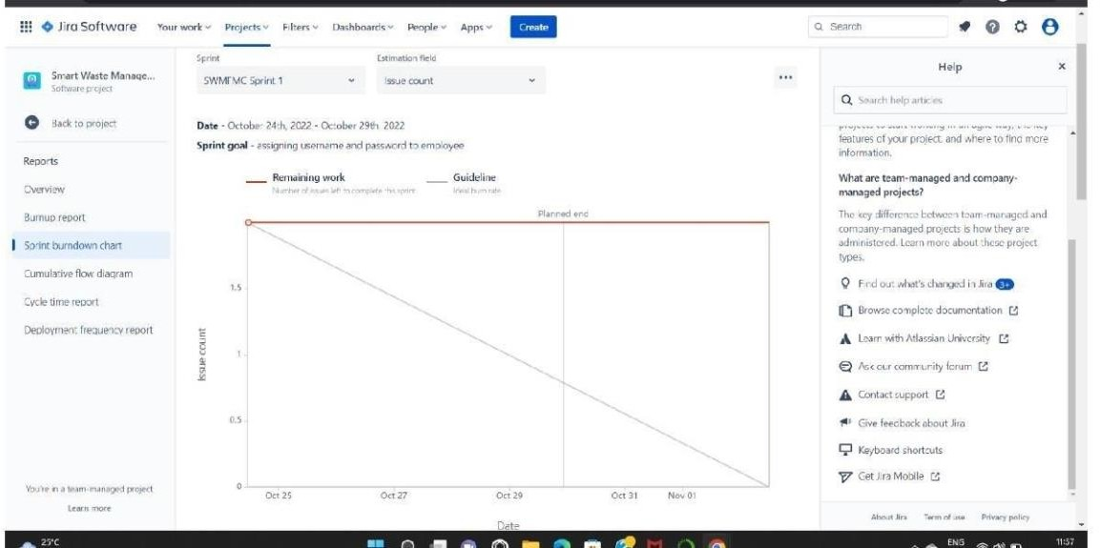

**Road map:**

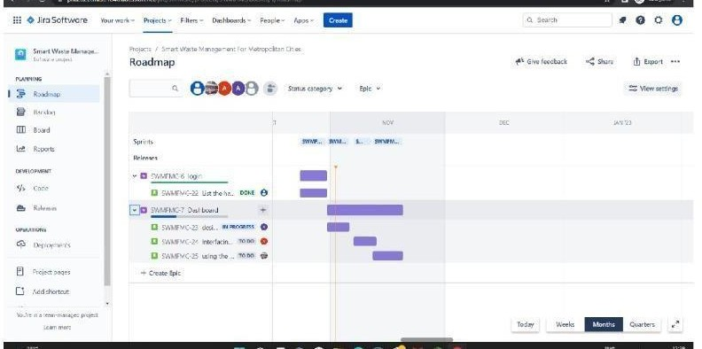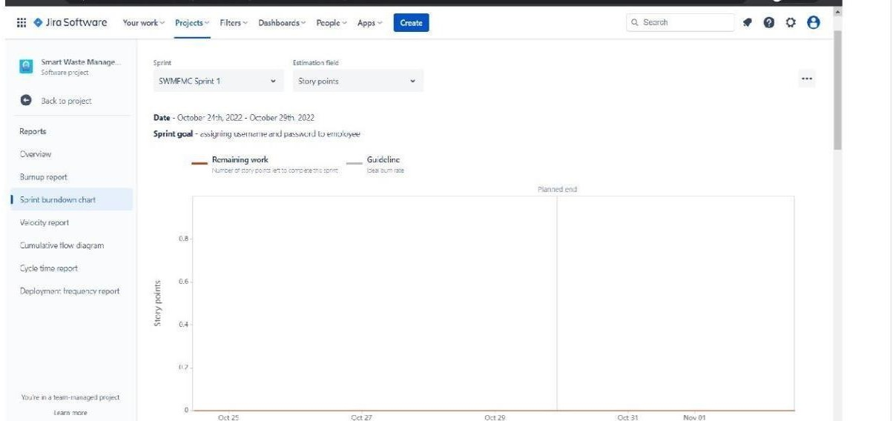

# CODING & SOLUTIONING:

## Feature 1- TRANSMIT DATA FROM WORKWI ACCOUNT TO

## IBM WATSOON IOT PLATFORM

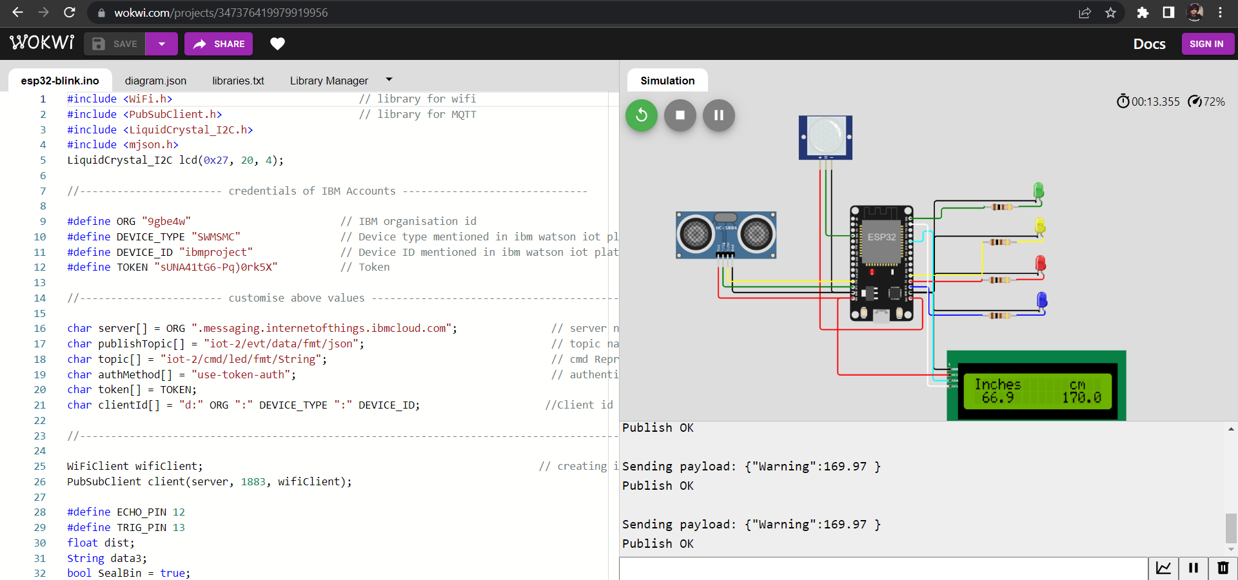

* 1. **Feature 2- LIVE UPDATE ON COLLECTED DATA:**

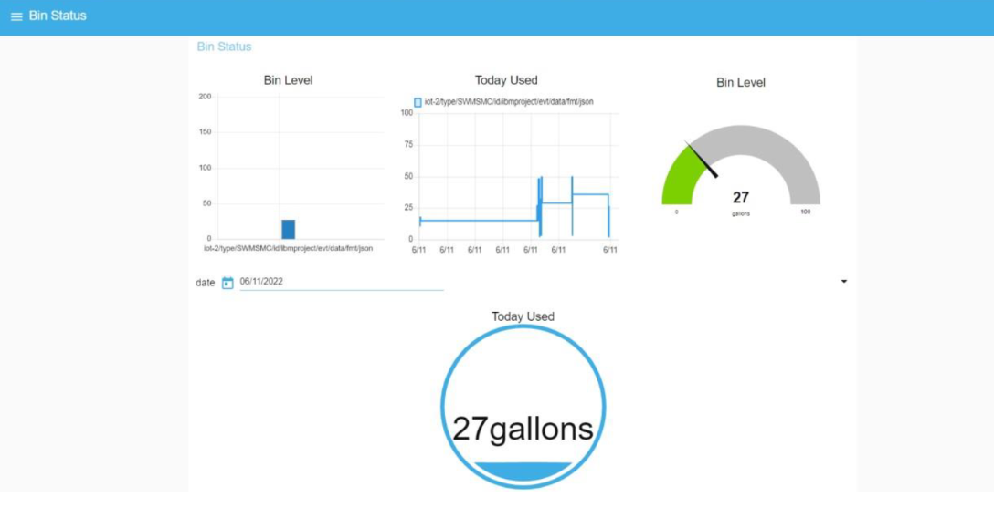

# Testing:

## Testcases:

|  |  |  |  |  |  |  |  |  |  |  |  |  |  |
| --- | --- | --- | --- | --- | --- | --- | --- | --- | --- | --- | --- | --- | --- |
| TEST CASE ID | FEATUR E TYPE | COM PO NENT | TEST SCENARI O | PR ER EQ UIS ITE | STEPS TO EXEC UT  E | TEST DATA | EXPEC TED RESUL T | ACTU AL RESUL T | STAT U S | CO MM ENT S | TC FOR AUTO M ATIO N( Y/N) | BU G ID | EXECUTED BY |
| LOGIN | FUNCTI | HOM | VERIFY |  | 1.ENT | https:// | L0gin | Workin | PASS | **Suc** |  |  | **SRIRAM V** |
| PAGE_TC | ONA L | E | THE USER | ER | 1 | page is | g as |  | **cess** |  |
| _001 |  | PAGE | IS ABLE | URL | 69.51.2 | visible | expecte |  | **ful** |  |
|  |  |  | TO SEE | AND | 0 |  | d |  |  |  |
|  |  |  | THE | CLICK | 4.219.3 |  |  |  |  |  |
|  |  |  | LOGIN/SI | GO | 0 |  |  |  |  |  |
|  |  |  | G | 2.VER | 106 |  |  |  |  |  |
|  |  |  | N UP | IFY |  |  |  |  |  |  |
|  |  |  | WEN | LOGI |  |  |  |  |  |  |
|  |  |  | USER | N/SI |  |  |  |  |  |  |
|  |  |  | CLICK ON | GN |  |  |  |  |  |  |
|  |  |  | MY | UP |  |  |  |  |  |  |
|  |  |  | ACCOUNT |  |  |  |  |  |  |  |
|  |  |  | BUTTON |  |  |  |  |  |  |  |

|  |  |  |  |  |  |  |  |  |  |  |  |  |  |
| --- | --- | --- | --- | --- | --- | --- | --- | --- | --- | --- | --- | --- | --- |
| LOGIN PAGE_TC  _002 | UI | HOM E PAGE | VERIFY THE USER IS ABLE TO SEE THE LOGIN/SI G  N UP WEN USER CLICK ON MY ACCOUNT BUTTON |  | 1.ENT ER URL AND CLICK GO 2.VER IFY LOGI N/SI GN UP  Eleme  nts a.ID  text  b o x  B  .  passw ord text box c..logi n butto n D.ne w user E.alre ady have an accou nt | https:// 1  69.51.2  0  4.219.3  0  106 | Applicat ion should show below UI  elemen t | Workin g as expecte d | PASS | Succ ess ful**l** |  |  | **RAGHUL S** |

|  |  |  |  |  |  |  |  |  |  |  |  |  |  |
| --- | --- | --- | --- | --- | --- | --- | --- | --- | --- | --- | --- | --- | --- |
| LOGIN PAGE_TC  _003 | FUNCTI ONA L | LOGI N PAGE | VERIFY THE USER IS ABLE TO SEE THE LOGIN/SI G  N UP WEN USER CLICK ON MY ACCOUNT BUTTON |  | 1.ent er url and click go 2.click on my accou nt 3.Ent er valid ID  4.Ent er valid passw ord 5.click on login | Id:1111  Password d:5678 | User should navigate your home page. | Working  as expectd | PASS | Succ ess ful |  |  | **PONSHAM S** |
|  |  |  |  |  | butto n |  |  |  |  |  |  |  |  |
| LOGIN | FUNCTI ONA | LOGI N | VERIFY |  | 1.ent er url | Id:1111 | Confirm | Workin | PASS | Succ ess |  |  | **SHARATH S** |

|  |  |  |  |  |  |  |  |  |  |  |  |  |  |
| --- | --- | --- | --- | --- | --- | --- | --- | --- | --- | --- | --- | --- | --- |
| PAGE_TC_ 004 | L | PAGE | THE USER  IS ABLE TO SEE |  | and click go 2.click on my account 3.Enter valid ID 4.Enter valid password 5.click on login  butvton | pass  wor d:56 | ation message sent | g as expecte d |  | ful |  |  |  |
|  |  |  | THE | 78 |  |  |  |
|  |  |  | LOGIN/SIG |  |  |  |  |
|  |  |  | N UP WEN |  |  |  |  |
|  |  |  | USER |  |  |  |  |
|  |  |  | CLICK ON |  |  |  |  |
|  |  |  | MY |  |  |  |  |
|  |  |  | ACCOUNT |  |  |  |  |
|  |  |  | BUTTON |  |  |  |  |
| LOGIN PAGE_TC_ 005 | UI | LOGIN PAGE | VERIFY THE USER IS ABLE TO SEE THE LOGIN/SIG N UP WEN  USER CLICK ON |  | 1.enter url and click go 2.click on my account 3.Enter valid ID  4.Enter valid | Id:1 111  pass wor d:56 78 | Confirm ation message sent | Workin g as expecte d | PASS | Success ful |  |  | **SHARATH S** |
|  |  |  | MY | password |  |  |  |  |  |
|  |  |  | ACCOUNT | 5.click |  |  |  |  |  |
|  |  |  | BUTTON | on login |  |  |  |  |  |
|  |  |  |  | button |  |  |  |  |  |
| LOGIN | FUNCTIONA | LOGIN | VERIFY |  | 1.enter url and click go 2.click on my account 3.Enter valid ID 4.Enter valid password 5.click on login  button | Id:1 | Custom | Workin | PASS | Success ful |  |  | **RAGHUL S** |
| PAGE_TC_ 006 | L | PAGE  FOR ADMIN | THE USER  IS ABLE TO SEE THE LOGIN/SIG N UP WEN | 111  pass wor d:56 78 | er  databas e is visible | g as  expecte d |  |  |
|  |  |  | USER |  |  |  |  |  |
|  |  |  | CLICK ON |  |  |  |  |  |
|  |  |  | MY |  |  |  |  |  |
|  |  |  | ACCOUNT |  |  |  |  |  |
|  |  |  | BUTTON |  |  |  |  |  |

* 1. **User acceptance Testing:**

### 1. Purpose of Document

The purpose of this document is to briefly explain the test coverage and open issues of the [ProductName] project at the time of the release to User Acceptance Testing (UAT).

### 2. Defect Analysis

This report shows the number of resolved or closed bugs at each severity level, and how they were resolved

|  |  |  |  |  |  |
| --- | --- | --- | --- | --- | --- |
| **Resolution** | **Severity 1** | **Severity 2** | **Severity 3** | **Severity 4** | **Subtotal** |
| By Design | 10 | 4 | 2 | 3 | 20 |
| Duplicate | 1 | 0 | 3 | 0 | 4 |
| External | 2 | 3 | 0 | 1 | 6 |
| Fixed | 11 | 2 | 4 | 20 | 37 |

|  |  |  |  |  |  |
| --- | --- | --- | --- | --- | --- |
| Not Reproduced | 0 | 0 | 1 | 0 | 1 |
| Skipped | 0 | 0 | 1 | 1 | 2 |
| Won't Fix | 0 | 5 | 2 | 1 | 8 |
| Totals | 24 | 14 | 13 | 26 | 7 |

### 1. Test Case Analysis:

This report shows the number of test cases that have passed, failed, and untested

|  |  |  |  |  |
| --- | --- | --- | --- | --- |
| **Section** | **Total Cases** | **Not Tested** | **Fai l** | **Pas s** |
| Print Engine | 7 | 0 | 0 | 7 |

|  |  |  |  |  |
| --- | --- | --- | --- | --- |
| Client Application | 51 | 0 | 0 | 51 |
| Security | 2 | 0 | 0 | 2 |
| Outsource Shipping | 3 | 0 | 0 | 3 |
| Exception Reporting | 9 | 0 | 0 | 9 |
| Final Report Output | 4 | 0 | 0 | 4 |
| Version Control | 2 | 0 | 0 | 2 |

# RESULTS:

* 1. **Performance Metrics:**

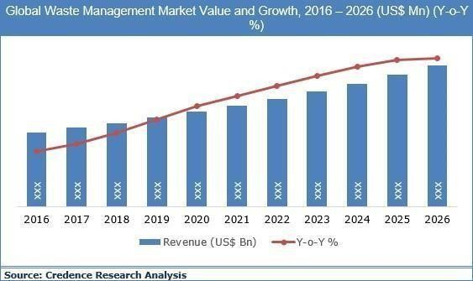

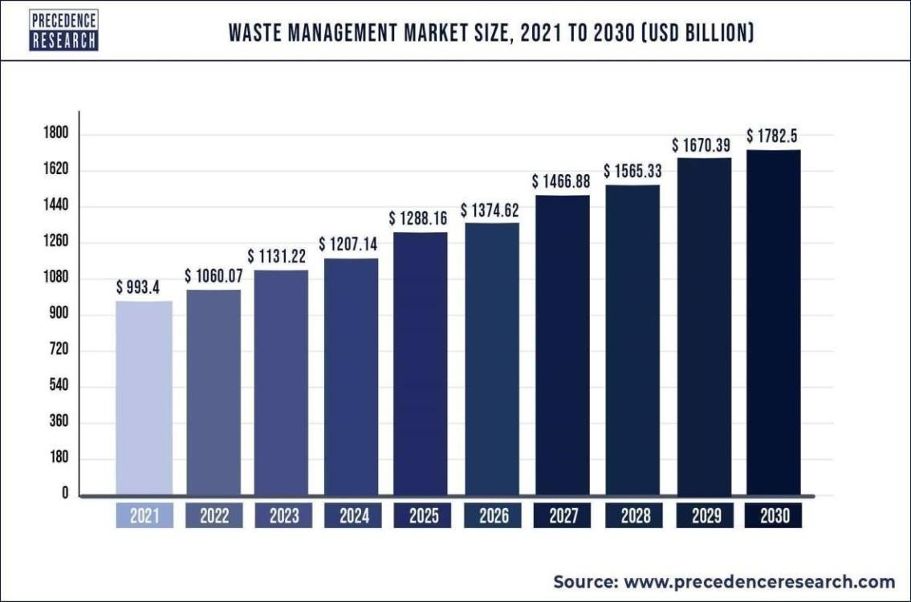

# ADVANTAGES & DISADVANTAGES

## ADVANTAGES:

* Reduction in Collection Cost
* No Missed Pickups
* Reduced Overflows
* Waste Generation Analysis • CO2 Emission Reduction

## DISADVANTAGES:

* System requires a greater number of waste bins for separate waste collection as per population in the city.
* This results into high initial cost due to expensive smart dustbins compare to other methods. Sensor nodes used in the dustbins have limited memory size.

# CONCLUSION:

A Smart Waste Management system that is more effective than the one in use now is achievable by using sensors to monitor the filling of bins. Our conception of a "smart waste management system" focuses on monitoring waste management, offering intelligent technology for waste systems, eliminating human intervention, minimizing human time and effort, and producing a healthy and trash-free environment. The suggested approach can be implemented in smart cities where residents have busy schedules that provide little time for garbage management. If desired, the bins might be put into place in a metropolis where a sizable container would be able to hold enough solid trash for a single unit. The price might be high.

# FUTURE SCOPE:

There are several future works and improvements for the proposed system, including the following:

1. Change the system of user authentication and atomic lock of bins, which would aid in protecting the bin from damage or theft.
2. The concept of green points would encourage the involvement of residents or end users, making the idea successful and aiding in the achievement of collaborative waste management efforts, thus fulfilling the idea of Swachh Bharath.
3. Having case study or data analytics on the type and times waste is collected on different days or seasons, making bin filling predictable and removing the reliance on electronic components, and fixing the coordinates.
4. Improving the Server's and Android's graphical interfaces

# 13. Appendix:

CODING:

**CODE FOR USER INTERFACE:**

**HTML CODE :**

<!DOCTYPE html>

<html lang="en">

<head>

<meta charset="UTF-8" />

<meta name="viewport" content="width=device-width, initial-scale=1.0" />

<title>Smart Waste Management System</title>

<!-- Bootstrap 4 CSS CDN -->

<link rel="stylesheet" href="https://cdnjs.cloudflare.com/ajax/libs/twitter-bootstrap/4.5.2/css/bootstrap.min.css" />

<!-- Fontawesome CSS CDN -->

<link rel="stylesheet" href="https://cdnjs.cloudflare.com/ajax/libs/font-awesome/5.14.0/css/all.min.css" />

<link rel="stylesheet" href="css/style.css" />

</head>

<body class="bg-info">

<div class="container">

<!-- Login Form Start -->

<div class="row justify-content-center wrapper" id="login-box">

<div class="col-lg-10 my-auto myShadow">

<div class="row">

<div class="col-lg-7 bg-white p-4">

<h1 class="text-center font-weight-bold text-primary">Sign in</h1>

<hr class="my-3" />

<form action="#" method="post" class="px-3" id="login-form">

<div class="input-group input-group-lg form-group">

<div class="input-group-prepend">

<span class="input-group-text rounded-0"><i class="far fa-envelope fa-lg fa-fw"></i></span>

</div>

<input type="email" id="email" name="email" class="form-control rounded-0" placeholder="E-Mail" required />

</div>

<div class="input-group input-group-lg form-group">

<div class="input-group-prepend">

<span class="input-group-text rounded-0"><i class="fasfa-key fa-lg fa-fw"></i></span>

</div>

<input type="password" id="password" name="password" class="form-control rounded-0" minlength="5" placeholder="Password"

required autocomplete="off" />

</div>

<div class="form-group clearfix">

<div class="custom-control custom-checkbox float-left">

<input type="checkbox" class="custom-control-input" id="customCheck" name="rem" />

<label class="custom-control-label" for="customCheck">Remember me</label>

</div>

<div class="forgot float-right">

<a href="#" id="forgot-link">Forgot Password?</a>

</div>

</div>

<div class="form-group">

<input type="submit" id="login-btn" value="Sign In" class="btn btn-primary btn-lg btn-block myBtn" />

</div>

</form>

</div>

<div class="col-lg-5 d-flex flex-column justify-content-center myColor p-4">

<h1 class="text-center font-weight-bold text-white">Welcome Friend!</h1>

<hr class="my-3 bg-light myHr" />

<p class="text-center font-weight-bolder text-light lead">Start your initiative to make your environment clean</p>

<button class="btn btn-outline-light btn-lg align-self-center font-weight-bolder mt-4 myLinkBtn" id="register-link">Sign Up</button>

</div>

</div>

</div>

</div>

<!-- Login Form End -->

<!-- Registration Form Start -->

<div class="row justify-content-center wrapper" id="register-box" style="display: none;">

<div class="col-lg-10 my-auto myShadow">

<div class="row">

<div class="col-lg-5 d-flex flex-column justify-content-center myColor p-4">

<h1 class="text-center font-weight-bold text-white">Welcome Back!</h1>

<hr class="my-4 bg-light myHr" />

<p class="text-center font-weight-bolder text-light lead">To stay connected Please login with your personal info.</p>

<button class="btn btn-outline-light btn-lg font-weight-bolder mt-4 align-self-center myLinkBtn" id="login-link">Sign In</button>

</div>

<div class="col-lg-7 bg-white p-4">

<h1 class="text-center font-weight-bold text-primary">Create Account</h1>

<hr class="my-3" />

<form action="#" method="post" class="px-3" id="register-form">

<div class="input-group input-group-lg form-group">

<div class="input-group-prepend">

<span class="input-group-text rounded-0"><i class="far fa-user fa-lg fa-fw"></i></span>

</div>

<input type="text" id="name" name="name" class="form-control rounded-0" placeholder="Full Name" required />

</div>

<div class="input-group input-group-lg form-group">

<div class="input-group-prepend">

<span class="input-group-text rounded-0"><i class="far fa-envelope fa-lg fa-fw"></i></span>

</div>

<input type="email" id="remail" name="email" class="form-control rounded-0" placeholder="E-Mail" required />

</div>

<div class="input-group input-group-lg form-group">

<div class="input-group-prepend">

<span class="input-group-text rounded-0"><i class="fasfa-key fa-lg fa-fw"></i></span>

</div>

<input type="password" id="rpassword" name="password" class="form-control rounded-0" minlength="5" placeholder="Password"

required />

</div>

<div class="input-group input-group-lg form-group">

<div class="input-group-prepend">

<span class="input-group-text rounded-0"><i class="fasfa-key fa-lg fa-fw"></i></span>

</div>

<input type="password" id="cpassword" name="cpassword" class="form-control rounded-0" minlength="5" placeholder="Confirm

Password" required />

</div>

<div class="form-group">

<div id="passError" class="text-dangerfont-weight-bolder"></div>

</div>

<div class="form-group">

<input type="submit" id="register-btn" value="Sign Up" class="btn btn-primary btn-lg btn-block myBtn" />

</div>

</form>

</div>

</div>

</div>

</div>

<!-- Registration Form End -->

<!-- Forgot Password Form Start -->

<div class="row justify-content-center wrapper" id="forgot-box" style="display: none;">

<div class="col-lg-10 my-auto myShadow">

<div class="row">

<div class="col-lg-7 bg-white p-4">

<h1 class="text-center font-weight-bold text-primary">Forgot Your Password?</h1>

<hr class="my-3" />

<p class="lead text-center text-secondary">To reset your password, enter the registered e-mail adddress and we will send you

password reset instructions on your e-mail!</p>

<form action="#" method="post" class="px-3" id="forgot-form">

<div id="forgotAlert"></div>

<div class="input-group input-group-lg form-group">

<div class="input-group-prepend">

<span class="input-group-text rounded-0"><i class="far fa-envelope fa-lg"></i></span>

</div>

<input type="email" id="femail" name="email" class="form-control rounded-0" placeholder="E-Mail" required />

</div>

<div class="form-group">

<input type="submit" id="forgot-btn" value="Reset Password" class="btn btn-primary btn-lg btn-block myBtn" />

</div>

</form>

</div>

<div class="col-lg-5 d-flex flex-column justify-content-center myColor p-4">

<h1 class="text-center font-weight-bold text-white">Reset Password!</h1>

<hr class="my-4 bg-light myHr" />

<button class="btn btn-outline-light btn-lg font-weight-bolder myLinkBtn align-self-center" id="back link">Back</button>

</div>

</div>

</div>

</div>

<!-- Forgot Password Form End -->

</div>

<!-- jQuery CDN -->

<script src="https://cdnjs.cloudflare.com/ajax/libs/jquery/3.5.1/jquery.min.js"></script>

<scriptsrc="js/script.js"></script>

</body>

</html>

**CSS CODE :**

@import url("https://fonts.googleapis.com/css?family=Maven+Pro:400,500,600,700,800,900&display=swap");

* {

margin: 0;

padding: 0;

box-sizing: border-box;

font-family: "Maven Pro",sans-serif;

}

.wrapper

{ height: 100vh;}

.myColor

{

background-image: linear-gradient(to right, #324bf3 50%, #f9d423 150%);

}

.myShadow {

box-shadow: 0 10px 10px rgba(0, 0, 0, 0.5);

}

.myBtn {

border-radius: 50px;

font-weight: bold;

font-size: 20px;

background-image: linear-gradient(to right, #0acffe 0%, #495aff 100%);

border: none;

}

.myBtn:hover {

background-image: linear-gradient(to right, #495aff 0%, #0acffe 100%);

}

.myHr {

height: 2px;

border-radius: 100px;

}

.myLinkBtn {

border-radius: 100px;

width: 50%;

border: 2px solid #fff;

}

@media (max-width: 720px) {

.wrapper {

margin: 2px;

}

}

JS CODE:

$(function () {

$("#register-link").click(function () {

$("#login-box").hide();

$("#register-box").show();

});

$("#login-link").click(function () {

$("#login-box").show();

$("#register-box").hide();

});

$("#forgot-link").click(function () {

$("#login-box").hide();

$("#forgot-box").show();

});

$("#back-link").click(function () {

$("#login-box").show();

$("#forgot-box").hide();

});

});

CODE FOR SENSOR:

Code for data transmission from IBM Watson to IOT PLATFORM:

|  |
| --- |
|  |
|  |
|  |  |
|  | #include <WiFi.h> // library for wifi |
|  | #include <PubSubClient.h> // library for MQTT |
|  | #include <LiquidCrystal_I2C.h> |
|  | LiquidCrystal_I2C lcd(0x27, 20, 4); |
|  |  |
|  | //----------------------- credentials of IBM Accounts ------------------------------ |
|  |  |
|  | #define ORG "9gbe4w" // IBM organisation id |
|  | #define DEVICE_TYPE "SWMSMC" // Device type mentioned in ibm watson iot platform |
|  | #define DEVICE_ID "ibmproject" // Device ID mentioned in ibm watson iot platform |
|  | #define TOKEN "sUNA41tG6-Pq)0rk5X" // Token |
|  |  |
|  | //----------------------- customise above values ----------------------------------------------------- |
|  |  |
|  | char server[] = ORG ".messaging.internetofthings.ibmcloud.com"; // server name |
|  | char publishTopic[] = "iot-2/evt/data/fmt/json"; // topic name and type of event perform and format in which data to be send |
|  | char topic[] = "iot-2/cmd/led/fmt/String"; // cmd Represent type and command is test format of strings |
|  | char authMethod[] = "use-token-auth"; // authentication method |
|  | char token[] = TOKEN; |
|  | char clientId[] = "d:" ORG ":" DEVICE_TYPE ":" DEVICE_ID; //Client id |
|  |  |
|  | //--------------------------------------------------------------------------------------------------------------------- |
|  |  |
|  | WiFiClient wifiClient; // creating instance for wificlient |
|  | PubSubClient client(server, 1883, wifiClient); |
|  |  |
|  | #define ECHO_PIN 12 |
|  | #define TRIG_PIN 13 |
|  | float dist; |
|  |  |
|  | void setup() |
|  | { |
|  | Serial.begin(115200); |
|  | pinMode(LED_BUILTIN, OUTPUT); |
|  | pinMode(TRIG_PIN, OUTPUT); |
|  | pinMode(ECHO_PIN, INPUT); |
|  | //pir pin |
|  | pinMode(34, INPUT); |
|  |  |
|  | //ledpins |
|  | pinMode(23, OUTPUT); |
|  | pinMode(2, OUTPUT); |
|  | pinMode(4, OUTPUT); |
|  | pinMode(15, OUTPUT); |
|  |  |
|  |  |
|  | lcd.init(); |
|  | lcd.backlight(); |
|  | lcd.setCursor(1, 0); |
|  | lcd.print(""); |
|  | wifiConnect(); |
|  | mqttConnect(); |
|  | } |
|  |  |
|  | float readcmCM() |
|  | { |
|  | digitalWrite(TRIG_PIN, LOW); |
|  | delayMicroseconds(2); |
|  | digitalWrite(TRIG_PIN, HIGH); |
|  | delayMicroseconds(10); |
|  | digitalWrite(TRIG_PIN, LOW); |
|  | int duration = pulseIn(ECHO_PIN, HIGH); |
|  | return duration * 0.034 / 2; |
|  | } |
|  |  |
|  | void loop() |
|  | { |
|  |  |
|  | lcd.clear(); |
|  |  |
|  | publishData(); |
|  | delay(500); |
|  | if (!client.loop()) |
|  | { |
|  | mqttConnect(); // function call to connect to IBM |
|  | } |
|  | } |
|  |  |
|  |  |
|  | /* --------------------------------retrieving to cloud-----------------------------------------------------*/ |
|  |  |
|  | void wifiConnect() |
|  | { |
|  | Serial.print("Connecting to "); |
|  | Serial.print("Wifi"); |
|  | WiFi.begin("Wokwi-GUEST", "", 6); |
|  | while (WiFi.status() != WL_CONNECTED) |
|  | { |
|  | delay(500); |
|  | Serial.print("."); |
|  | } |
|  | Serial.print("WiFi connected, IP address: "); |
|  | Serial.println(WiFi.localIP()); |
|  | } |
|  | void mqttConnect() |
|  | { |
|  | if (!client.connected()) |
|  | { |
|  | Serial.print("Reconnecting MQTT client to "); |
|  | Serial.println(server); |
|  | while (!client.connect(clientId, authMethod, token)) |
|  | { |
|  | Serial.print("."); |
|  | delay(500); |
|  | } |
|  | initManagedDevice(); |
|  | Serial.println(); |
|  | } |
|  | } |
|  | void initManagedDevice() |
|  | { |
|  | if (client.subscribe(topic)) |
|  | { |
|  | Serial.println("IBM subscribe to cmd OK"); |
|  | } |
|  | else |
|  | { |
|  | Serial.println("subscribe to cmd FAILED"); |
|  | } |
|  | } |
|  | void publishData() |
|  | { |
|  | float cm = readcmCM(); |
|  |  |
|  | if(digitalRead(34)) //pir motion detection |
|  | { |
|  | Serial.println("Motion Detected"); |
|  | Serial.println("Lid Opened"); |
|  | digitalWrite(15, HIGH); |
|  |  |
|  | } |
|  | else |
|  | { |
|  | digitalWrite(15, LOW); |
|  | } |
|  |  |
|  | if(digitalRead(34)== true) |
|  | { |
|  | if(cm <= 100) //Bin level detection |
|  | { |
|  | digitalWrite(2, HIGH); |
|  | Serial.println("High Alert!!!,Trash bin is about to be full"); |
|  | Serial.println("Lid Closed"); |
|  | lcd.print("Full! Don't use"); |
|  | delay(2000); |
|  | lcd.clear(); |
|  | digitalWrite(4, LOW); |
|  | digitalWrite(23, LOW); |
|  | } |
|  | else if(cm > 150 && cm < 250) |
|  | { |
|  | digitalWrite(4, HIGH); |
|  | Serial.println("Warning!!,Trash is about to cross 50% of bin level"); |
|  | digitalWrite(2, LOW); |
|  | digitalWrite(23, LOW); |
|  | } |
|  | else if(cm > 250 && cm <=400) |
|  | { |
|  | digitalWrite(23, HIGH); |
|  | Serial.println("Bin is available"); |
|  | digitalWrite(2,LOW); |
|  | digitalWrite(4, LOW); |
|  | } |
|  | delay(10000); |
|  | Serial.println("Lid Closed"); |
|  | } |
|  | else |
|  | { |
|  | Serial.println("No motion detected"); |
|  | } |
|  |  |
|  |  |
|  |  |
|  |  |
|  |  |
|  | if(cm <= 100) |
|  | { |
|  | digitalWrite(21,HIGH); |
|  | String payload = "{\"High Alert!!\":\""; |
|  | payload += cm; |
|  | payload += "left\" }"; |
|  | Serial.print("\n"); |
|  | Serial.print("Sending payload: "); |
|  | Serial.println(payload); |
|  |  |
|  | if (client.publish(publishTopic, (char*) payload.c_str())) // if data is uploaded to cloud successfully,prints publish ok else prints publish failed |
|  | { |
|  | Serial.println("Publish OK"); |
|  | } |
|  | } |
|  | if(cm <= 250) |
|  | { |
|  | digitalWrite(22,HIGH); |
|  | String payload = "{\"Warning!!\":\""; |
|  | payload += dist; |
|  | payload += "left\" }"; |
|  | Serial.print("\n"); |
|  | Serial.print("Sending distance: "); |
|  | Serial.println(cm); |
|  | if(client.publish(publishTopic, (char*) payload.c_str())) |
|  | { |
|  | Serial.println("Publish OK"); |
|  | } |
|  | else |
|  | { |
|  | Serial.println("Publish FAILED"); |
|  | } |
|  | } |
|  |  |
|  | float inches = (cm / 2.54); //print on lcd |
|  | lcd.setCursor(0,0); |
|  | lcd.print("Inches"); |
|  | lcd.setCursor(4,0); |
|  | lcd.setCursor(12,0); |
|  | lcd.print("cm"); |
|  | lcd.setCursor(1,1); |
|  | lcd.print(inches, 1); |
|  | lcd.setCursor(11,1); |
|  | lcd.print(cm, 1); |
|  | lcd.setCursor(14,1); |
|  | delay(1000); |
|  | lcd.clear(); |
|  | } |
|  |  |

OUTPUT SCREENSHOTS:

USER INTERFACE:

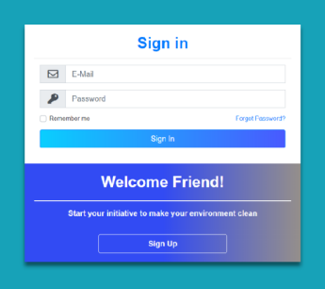

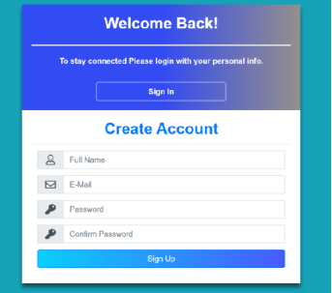

SENSOR WORKUP CONNECTION SCREENSHOT:





**GitHub Link:**

https://github.com/IBM-EPBL/IBM-Project-27774-1660065289

